TITLE: Non-myeloablative allogeneic stem cell transplantation for non-malignant hematologic disease

SEUNG-HWAN SHIN¹, SUNG-SOO PARK², SILVIA PARK², YOUNG-WOO JEON², JAE-HO YOON², YAHNG SEUNG-AH³, BYUNG-SIK CHO², YOO-JIN KIM², SEOK LEE², HEE-JE KIM², CHANG-KI MIN², SEOK-GOO CHO², DOONG-WOOK KIM², JONG-WOOK LEE², and KI-SEONG EOM²

¹Department of Hematology, Yeouido St. Mary’s Hospital, College of Medicine, The Catholic University of Korea, Seoul, Republic of Korea.
²Catholic Hematology Hospital, Seoul St. Mary’s Hospital, College of Medicine, The Catholic University of Korea, Seoul, Republic of Korea.
³Department of Hematology, Incheon St. Mary’s Hospital, College of Medicine, The Catholic University of Korea, Incheon, Republic of Korea.

Allogeneic stem cell transplantation (SCT) using non-myeloablative conditioning for hereditary red cell disease allowed stable mixed chimerism with less toxicities, a considerable proportion of patients could not discontinue immunosuppressant. We developed a strategy of matched-sibling donor peripheral blood SCT using non-myeloablative conditioning, with performing an additional stem cells infusion (booster) if T-cell chimerism significantly decreases. Post-transplant outcomes of 13 benign hematologic disease patients, to whom our strategy has been applied, were analyzed. Our conditioning consisted of alemtuzumab (1 mg/kg) plus fractionated total-body irradiation (300–400 cGy). If T-cell chimerism declined to ≤ 25% at any time or ≤ 50% at 1 year, patients received a booster after total-nodal irradiation (500 cGy). Sirolimus (a target level of 10–15 ng/mL for the first 3–4 months, and then near 10 ng/mL for the 8–9 months) was administered for the graft-versus-host disease prophylaxis and stable chimerism maintenance. The median age of patients was 32 (range, 24–66) years. Two (15.4%) and three (23.1%) patients did not experience neutrophil and platelet nadirs, respectively. Others achieved neutrophil and platelet engraftment at a median 14 (range, 8-20) and 13.5 (range, 10-25) days, respectively. Only chronic graft-versus-host disease was observed in one (7.7%) patient at 11.2 months. At median 18.5 (range, 3.9–37.6) months, 6 (46.2%) patients received a booster, following declined T-cell chimerism of median 30% (range, 17–41). Thereafter, T-cell chimerism recovered to > 80%. With a median follow-up of 11.0 (range, 1.0–38.1) months, transplant-related or disease-related death were not observed. At last follow-up, 3 (50.0%) of 6 patients with follow-up duration of ≥ 1 year ceased immunosuppressant, with a median PB T-cell chimerism of 96% (range, 90–99). Our preliminary study suggests that our strategy can be an attractive option for patients with non-malignant hematologic diseases.

Methods

PATIENTS AND METHODS

Transplant-related procedures
Patients received a non-myeloablative conditioning regimen of alemtuzumab (Campath 1-H; 0.03 mg/kg for 1 day, 0.1 mg/kg for 1 day, then 0.3 mg/kg for 3 days; total dose 1.03 mg/kg on day -7 to -3) plus fractionated total body irradiation (TBI; 300–400 cGy for 1 day on day -2). Subsequently, PB stem cells (target CD34+ cell dose of 10×10 6 /kg) which were mobilized with granulocyte-colony stimulating agent (G-CSF; 10 µg/kg filgrastim for 4 days) from matched sibling donors (MSD) were administered to them. For the graft-versus-host disease prophylaxis and maintaining stable engraftment, patients took a sirolimus of 5 mg/day, followed by dose adjustment of target trough level of 10–15 ng/ml for 12 months, after loading dose of 15 mg/day on day -1. Subsequently, we carefully performed the tapering and discontinuing of sirolimus to those who maintained to be patient’s donor T-cell chimerism of ≥ 50%. If patients’ donor T-cell chimerism declined to be &lt; 25% at any time or &lt; 50% after one year, they received additional stem cell infusion (target CD34+ cell dose of 10×10 6 /kg) after 500 cGy total-nodal irradiation (TNI).

Supportive care

Results

Patients’ demographic and disease-related characteristics

Between February 2015 and March 2018, 13 patients received our strategy of a non-myeloablative (NMA) conditioning allogeneic stem cell transplantation (SCT) from matched sibling donor (MSD) with an optionally additional stem cells infusion, depending on donors’ peripheral blood (PB) T-cell chimerism, at our institution. They had benign hematologic diseases of transplant-indicated β-thalassemia major in five (38.5%), sickle cell anemia in four (30.8%), secondary myelofibrosis from essential thrombocythemia or polycythemia vera in two (15.4%), and hypogammaglobulinemia in one (7.7%) patient. At transplantation, the median age of patients was 32 (range, 24–66) years old. Although they had adequate organ functions being tolerable to the procedure, the proportions of patients having Eastern Cooperative Oncology Group (ECOG) performance state (PS) ≥ 2 and hematopoietic cell transplantation-specific co-morbidity index (HCT-CI) ≥ 3 were 18.2% (95% confidence interval [CI], 1.9–45.4) and 46.2% (95% CI, 19.2–74.9), respectively. The proportion of female donor to male recipient transplantation was 18.2% (95% CI, 1.9–45.4). More detailed patients’ demographic and disease-related characteristics were described in Table 1.

Major transplant-related outcomes of initial NMA conditioning allogeneic SCT from MSD

All patients received PB stem cells infusion of median CD34+ cells of 14.9×10⁶/kg (range, 6.56–33.27) and CD3+ cells of 567.2 (range, 158.2–843.4), following NMA conditioning. Two (15.4%) and three (23.1%) patients did not experience neutrophil (< 0.5×10⁹/L) and platelet (< 50×10⁹/L) nadirs, respectively. Other patients achieved neutrophil and platelet engraftments at median 14 days (range, 8–20) and 13.5 days (range, 11–25), respectively. Median PB donor’s T-cell chimerism at 1 month was 86% (range, 14–97) (Figure 1). The cumulative incidences of neutrophil and platelet engraftments at day 28 were 100% in both. No patient experienced acute and chronic graft-versus-host disease (GVHD). The cumulative incidences of acute at day 100 and chronic GVHD at 12 months were 0% in both. The infectious complication of grade ≥ 3, cytomegalovirus (CMV) reactivation requiring pre-emptive therapy, and herpes zoster were observed in two (15.4%), one (7.7%), and two (15.4%) patients, respectively. The declines of PB donor’s T-cell chimerism to ≤ 25% (median 20.0% [range,1–25]) before 12 months (at a median 6.1 months [range, 2.8–6.2]) in 4 (30.8%) patients and ≤ 50% (median 38.5% [range, 30-41%] after 12 months (at a median 17.8 months [range, 13.5–36.4]) in 4 (30.8%) patients were observed (Figure 1). Subsequently, they received an additional stem cells infusion at a median 11.7 month (range, 2.9–37.6), with median PB donor’s T-cell chimerism of 27.5% (range, 1–41) (Figure 1). The additional stem cell infusion-free survival rates at 12 and 24 months were 69.2% (95% CI, 37.3–87.2) and 34.6% (95% CI, 7.2–65.2), respectively (Figure 2). Transplant-related mortality was not observed in any patient. Two (40.0%) of five patients who did not receive an additional stem cells infusion could successfully discontinue sirolimus at 13.2 and 18.4 months, respectively.

Major transplant-related outcomes after an additional stem cells infusion

Eight (61.5%) patients who received an additional stem cells infusion of median CD34+ cells of 14.9×10⁶/kg (range, 6.56–33.27) and CD3+ cells of 567.2 (range, 158.2–843.4), following TNI conditioning, did not experience neutrophil and platelet nadirs at all. At a median 0.3 months (range, 0.2–0.4), two (25.0%) patients experienced acute GVHD grade III. One patient died of acute respiratory distress syndrome, which occurred during steroid treatment for acute GVHD. Other patient experienced complete response of acute GVHD after a short-course steroid treatment. The cumulative incidence of aGVHD grade III–IV at day 100 was 7.7% (95% CI, 0–21.1). At a median 1.7 months (range, 1.3 – 2.5), two (28.6%) patients experienced moderate and severe chronic GVHD, respectively. One patient suffered from persistent chronic GVHD, although she received 4 courses of rituximab (375 mg/m²) administrations, followed by ruxolitinib (10 mg/day) maintenance. Another patient remained to be tolerable after experiencing partial response after steroid-based treatment for chronic GVHD. The cumulative incidences of moderate-to-severe and severe cGVHD at 12 months were 27.5% (95% CI, 2.8–62.7) and 14.3% (95% CI, 0.5–49.6), respectively. The infectious complication of grade ≥ 3, cytomegalovirus (CMV) reactivation requiring pre-emptive therapy, and herpes zoster were observed in two (15.4%), one (7.7%), and two (15.4%) patients, respectively.

Table 1. Patients’ demographic and disease-related characteristics
UPN | Age | Sex | PS | CI | Diagnosis | Cause of transplant
01 | 33 | M | 1 | 4 | β-thalassemia major
02 | 47 | F | 1 | 3 | Secondary myelofibrosis from polycythemia vera | High IPSS, D-IPSS, D-IPSS+
03 | 34 | M | 1 | 5 | β-thalassemia major
04 | 27 | F | 1 | 0 | Sickle cell β-thalassemia (homozygous HbSS), companying α-thalassemia silent carrier
05 | 66 | F | 1 | 5 | Secondary myelofibrosis from essential thrombocythemia | High IPSS, D-IPSS, D-IPSS+
06 | 33 | M | 2 | 2 | Sickle cell anemia (homozygous HbSS type), companying α-thalassemia silent carrier
07 | 26 | F | 1 | 2 | Sickle cell anemia (homozygous HbS/β type), companying α-thalassemia trait
08 | 31 | F | 1 | 3 | β-thalassemia major, companying α-thalassemia silent carrier
09 | 24 | F | 1 | 3 | Sickle cell anemia
10 | 29 | M | 2 | 2 | β-thalassemia major
11 | 34 | M | 1 | 2 | β-thalassemia major, companying α-thalassemia silent carrier
12 | 32 | F | 1 | 2 | Hypogammaglobulinemia
13 | 25 | F | 1 | 2 | β-thalassemia major, companying α-thalassemia trait

Figure 1.
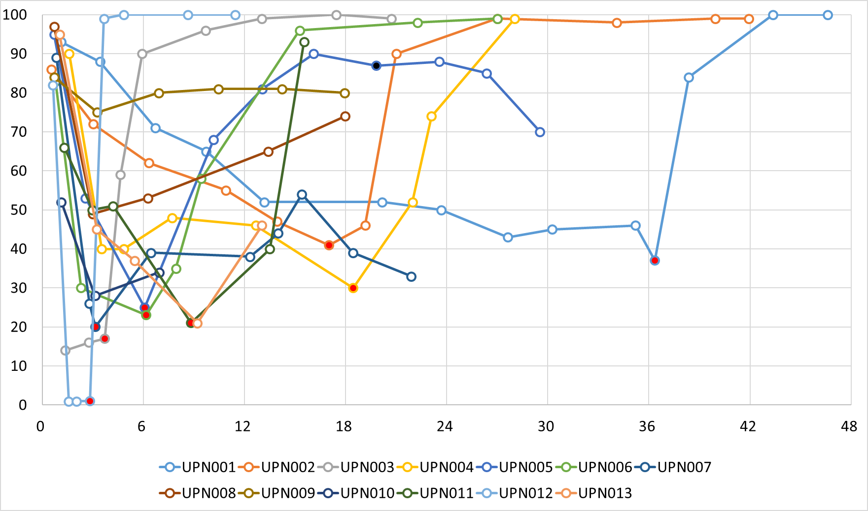
Figure 2. Optionally additional stem cells infusion-free survival rate
